Preparation of extended abstracts for CACRCS Workshop Capacity Assessment of Corroded Reinforced Concrete Structures (The title should not exceed 120 characters and contain no abbreviations)
Name Surname¹, Name Surname², Name Surname³
¹ Department of Civil and Environmental Engineering, Politecnico di Milano, Milan, Italy
² Department of, University of, City, Country
³ Department of, University of, City, Country

Abstract
This document is a template which you should use for preparing extended abstracts for the conference. Do not change the font sizes or line spacing to squeeze more text into a limited number of pages. Do not cite references in the abstract. The abstract should clearly state the motivation for your research, the key goal of your project and the methods (experimental and/or numerical) used in order to reach the goal. The focus should be placed on the results, summarizing these in approximately 2 to 3 sentences. The abstract should not exceed 750 characters. For the formatting please use the format “004.Abstract”.
- Extended abstract format
The page size should be set to 17 cm x 24 cm with the setting “opposite pages” activated (so that WORD differs between a left and a right page). The top and bottom margins should be set to 1.5 cm. The inner margin is to be set to 2.5 cm. The outer margin is to be set to 1.5 cm. For the top and bottom captions please use 0.90 cm margin. Total number of pages for your extended abstract should be 4 pages, including figures, tables, references, acknowledgements and appendices. Large blank spaces are not acceptable. The extended abstract should be formatted in both MSword and PDF and submitted by on-line submission system. Total size of two files is limited to 10.0 MB (megabytes).
- Heading formats
For the headings please use the given headings formats
- 01.Heading 1: for the first level headline with Arial 9 pt, bold type, line spacing min. 10 pt, spacing above 12 pt, below 4 pt
- 02.Heading 2: for the second level headline with Arial 9 pt, bold type line spacing min. 10 pt, spacing above 8 pt, below 0 pt
- 03. Heading 3: for the third level headline with Arial 9 pt, normal type line spacing min. 10 pt, spacing above 6 pt, below 0 pt
- Paragraph formats
For the first paragraph after a heading, a figure or a table, please use the format “0a.FlowText.FirstParagraph”. The paragraph does then show no indentation and the line spacing is set to min. 10 pt with a character size of 9 pt. Above each paragraph you should provide 4 pt space. The font should be Times New Roman. Hyphenation should be turned on for the entire document. Language should be set to English.
All following paragraphs should be formatted in “0b.FlowText.FollowingParagraph” with 0.5 cm indentation, line spacing min. 10 pt and character size of 9 pt. The font should be Times New Roman. Below each paragraph there should be 0 pt space.
When preparing your abstract or paper, please use all possible help to prevent orthographical errors, as the Scientific Committee will not correct your language.
In order to generate a new paragraph press enter. For just creating a line break within a paragraph press “shift-enter”. In order to prevent undesired line breaks use “ctrl+shift+space” instead of just pressing space, as for example when wanting to keep numbers and the respective units in one line.
  - Subheader (Format “02.Heading2”)
    - Subheader (Format “03.Heading3”)
For the headings please also use the appropriate heading formats, i.e. 01.Heading1, 02.Heading2 or 03.Heading3.
When inserting a picture, please make sure the graph is embedded in the word file. The figure caption should be placed below the figure. Sometimes it might be appropriate to insert two figures next to each other. Please then refer to these figures as Fig. 1 (left) and (right). The resolution of line graphs should be chosen to at least 600 dpi. We recommend to use the TIF format for insertion. For bitmap pictures a resolution of 300 dpi is sufficient.

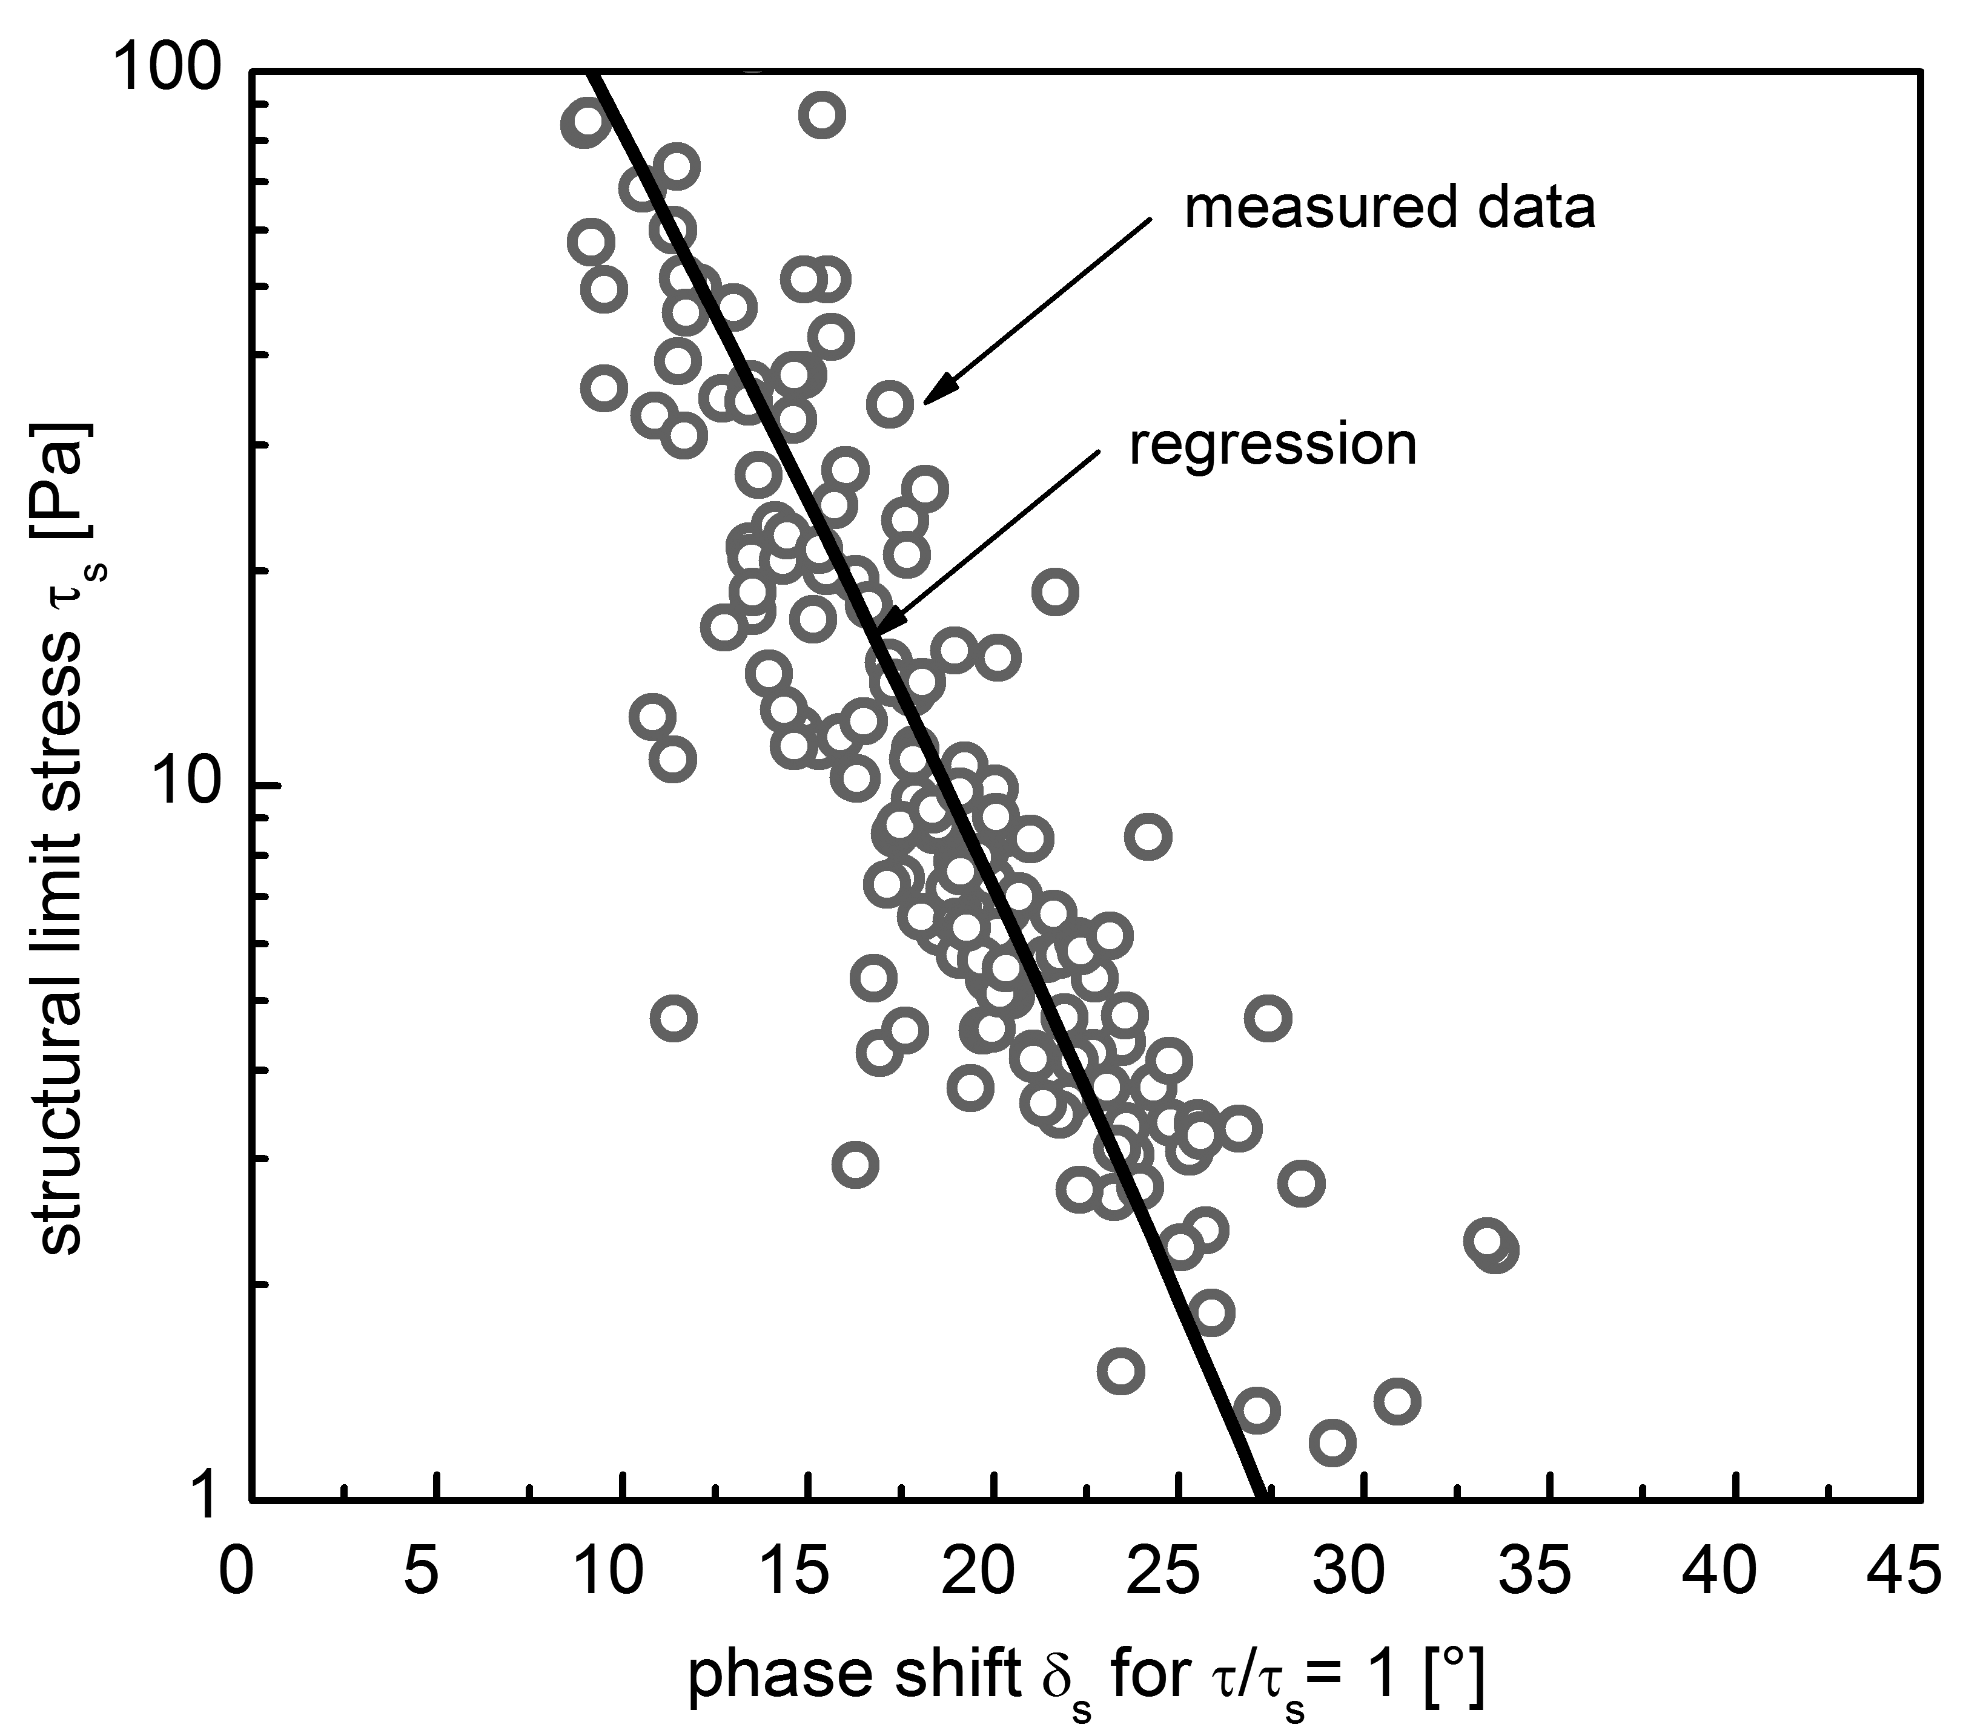
Fig. 1 Figure captions should be indented 1.5 cm. The caption itself should use 9 pt, Times New Roman, identical to the standard setup for paragraphs. For large pictures, we highly recommend to shrink the pictures size using a graphics programme and not to use MS Word, in order to prevent large file sizes.
The format of the next paragraph after a graph should be 0a.FlowText.FirstParagraph. When inserting a table, please stick to the example given below. The text in the table should be formatted in Times New Roman, size 9 pt, line spacing min. 10 pt.
Table 1 Table captions should be indented 1.5 cm. The caption itself should use 9 pt , Times New Roman, identical to the standard setup for paragraphs. After the table caption and the table there should be 2 pt space.
Margin | Dimension | Value | Comment
top | [cm] | 1.50 | first column to be formatted with left orientation
bottom | [cm] | 1.50 | columns with values to be formatted with centred orientation
inner side | [cm] | 2.50 | -
outer side | [cm] | 1.50 | -

There should be a blank line between the table and the following paragraph. The format of the paragraph should be 0a.FlowText.FirstParagraph.
  - References
Number citations consecutively in square brackets [1]. The sentence punctuation follows the brackets [2]. Multiple references [2], [3] are each numbered with separate brackets [1]–[3]. When citing a section in a book, please give the relevant page numbers. In sentences, refer simply to the reference number, as in [3]. Do not use “Ref. [3]” or “reference [3]” except at the beginning of a sentence: “Reference [3] shows ....”. Do not use footnotes or endnotesin your paper.
  - Equations
Use either the Microsoft Equation Editor or the MathType add-on (http://www.mathtype.com) for equations in your paper (Insert | Object | Create New | Microsoft Equation or MathType Equation). “Float over text” should not be selected. Number equations consecutively with equation numbers in parentheses, as in (1).
(1)
  - Editorial policy
Submission of a manuscript is not required for participation in a conference. Do not submit a paper you have submitted or published elsewhere. The submitting author is responsible for obtaining agreement of all coauthors and any consent required from sponsors before submitting a paper.
Acknowledgements
Authors wishing to acknowledge assistance or encouragement from colleagues, special work by technical staff or financial support from organizations should do so in an unnumbered Acknowledgments section immediately following the last numbered section of the paper.
References
- Pollan, Michael. 2006. The Omnivore’s Dilemma: A Natural History of Four Meals. New York: Penguin. Citation example of book
- Ward, Geoffrey C., and Ken Burns. 2007. The War: An Intimate History, 1941–1945. New York: Knopf. Citation example of book
- Austen, Jane. 2007. Pride and Prejudice. New York: Penguin Classics. Kindle edition. Citation example of book published electronically
- Kurland, Philip B., and Ralph Lerner, eds. 1987. The Founders’ Constitution. Chicago: University of Chicago Press. http://press-pubs.uchicago.edu/founders/. Citation example of book published electronically
- Weinstein, Joshua I. 2009. “The Market in Plato’s Republic.” Classical Philology 104:439–58. Citation example of journal article
- Kossinets, Gueorgi, and Duncan J. Watts. 2009. “Origins of Homophily in an Evolving Social Network.” American Journal of Sociology 115:405–50. Accessed February 28, 2010. doi:10.1086/599247. Citation example of article in an online journal
- Choi, Mihwa. 2008. “Contesting Imaginaires in Death Rituals during the Northern Song Dynasty.” PhD diss., University of Chicago. Citation example of thesis or dissertation
- Adelman, Rachel. 2009. “ ‘Such Stuff as Dreams Are Made On’: God’s Footstool in the Aramaic Targumim and Midrashic Tradition.” Paper presented at the annual meeting for the Society of Biblical Literature, New Orleans, Louisiana, November 21–24. Citation exaple of paper presented at a meeting or conference
- McDonald’s Corporation. 2008. “McDonald’s Happy Meal Toy Safety Facts.” Accessed July 19. http://www.mcdonalds.com/corp/about/factsheets.html. Citation example of website

